**Installation Manual**

The following document explains how to install the SchuleMath App. First you need to download the file „app-release.apk“ and save in a directory in the Android device.  
  
There are 3 important fact fort he installation:  
  
1. Allow the device to install Unknown Sources Applications.

2. Installation.

3. Uninstalling the App.

1. **Allow the device to install Unknown Sources Applications**

This step is necessary to intall an App with an APK file.

**1.1** Go to Settings 🡪 Options 🡪 Security

**1.2** In the next screen check the option „Unknown Sources“.

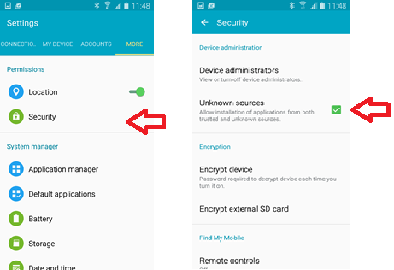

1. **Installation**

**2.1** Go to the path in your device where the APK file is stored and click on it.

**2.2** In the next screen press Install. (The App records some information in the device memory, that is why it ask for permisions before the installation).

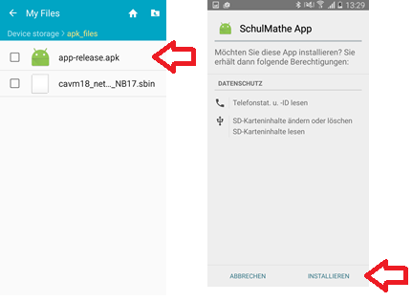

1. **Uninstall the App**

Before installing an update, the last version oft he App should be uninstall.  
  
**3.1** Go to Settings 🡪 Options 🡪 Application Manager

**3.2** In the „Installed Apps“ list look for „SchulMathe_App“ and click on it.

**3.3** In the next screen press „Uninstall“.

